**BANGLADESH UNIVERSITY OF ENGINEERING AND TECHNOLOGY**



**Department of Electrical and Electronic Engineering**

**Course No. :** EEE 416

**Course Title:** Microprocessor and Interfacing Laboratory

**Arithmetic of Signed Integers, Double Precision, BCD and**

**Floating Point Numbers in 8086**

**Name:** Mir Sayeed Mohammad

**ID:** 1606003

**Level:** 4

**Term:** 1

**Section:** A

**Submission Deadline:** 03 - 06 -2021

**Problem 1**

Adding two 16 bit numbers and multiplying the result with another 16 bit number

**Assembly Code:**

CODE SEGMENT

ASSUME CS:CODE, DS:CODE

; ******************* MAIN ******************* ;

MOV AX, A

ADD AX, B

MOV S, AX

ADC S+2, 0 ; S+2:S = A+B

MOV CX, C

MUL CX

MOV P, AX

MOV P+2, DX

MOV AX, S+2

MUL CX

ADD AX, P+2

MOV P+2, AX

ADC P+4, 0

HLT

; ******************* DATA ******************* ;

A DW 0F042H

B DW 0ECFFH

C DW 321BH

S DW ?, ?

P DW ?, ?, ?

CODE ENDS

END

**Result:**

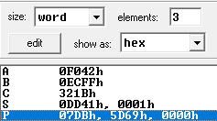

Fig: Output matching the example in problem statement

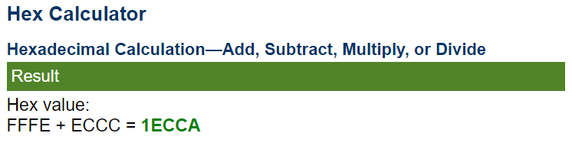

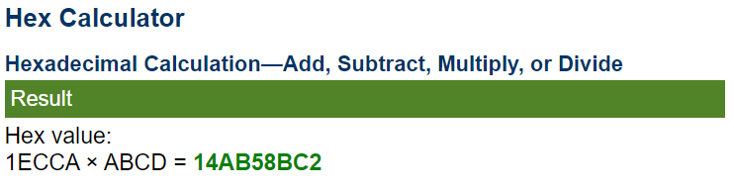

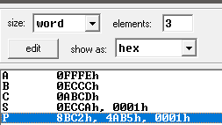

Fig: Second demonstration using different values and comparing to online calculator

**Problem 2**

Adding two 16 bit numbers and multiplying the result with another 16 bit number

**Assembly Code:**

CODE SEGMENT

ASSUME CS:CODE, DS:CODE

; ******************* MAIN ******************* ;

; C+4:C+2:C = A+2:A x B

MOV BX, B

MOV AX, A

MUL BX

MOV C, AX

MOV C+2, DX

MOV AX, A+2

MUL BX

ADD AX, C+2

ADC DX, 0

MOV C+2, AX

MOV C+4, DX

; C+6:C+4:C+2 = A+2:A x B+2 + C+4:C+2

MOV BX, B+2

MOV AX, A

MUL BX

ADD AX, C+2

ADC DX, C+4

ADC CX, 0

MOV C+2, AX

MOV C+4, DX

MOV C+6, CX

MOV AX, A+2

MUL BX

ADD AX, C+4

ADC DX, C+6

MOV C+4, AX

MOV C+6, DX

HLT

; ******************* DATA ******************* ;

A DW 0BA98H, 0FEDCH

B DW 03210H, 07654H

C DW ?, ?, ?, ?

CODE ENDS

END

**Result:**

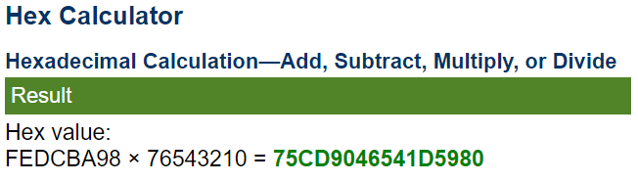

Fig: Multiplication result from online calculator

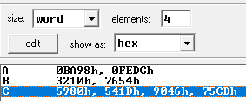

Fig: Result matching with online calculator